**Lab 2**

**Introduction**

The purpose of this lab was to introduce the R-2R ladder, Monte Carlo simulations, and the relation between resistor costs and their tolerance. The R-2R ladder section displayed the trivialness of the equivalent resistance of the circuit. Within the Monte Carlo simulations, we measured the voltage range of resistors using different tolerances. Finally, we tied up the proportionality between resistor cost and its tolerance.

**Discussion**

**2.5.1 Equivalent Resistance**

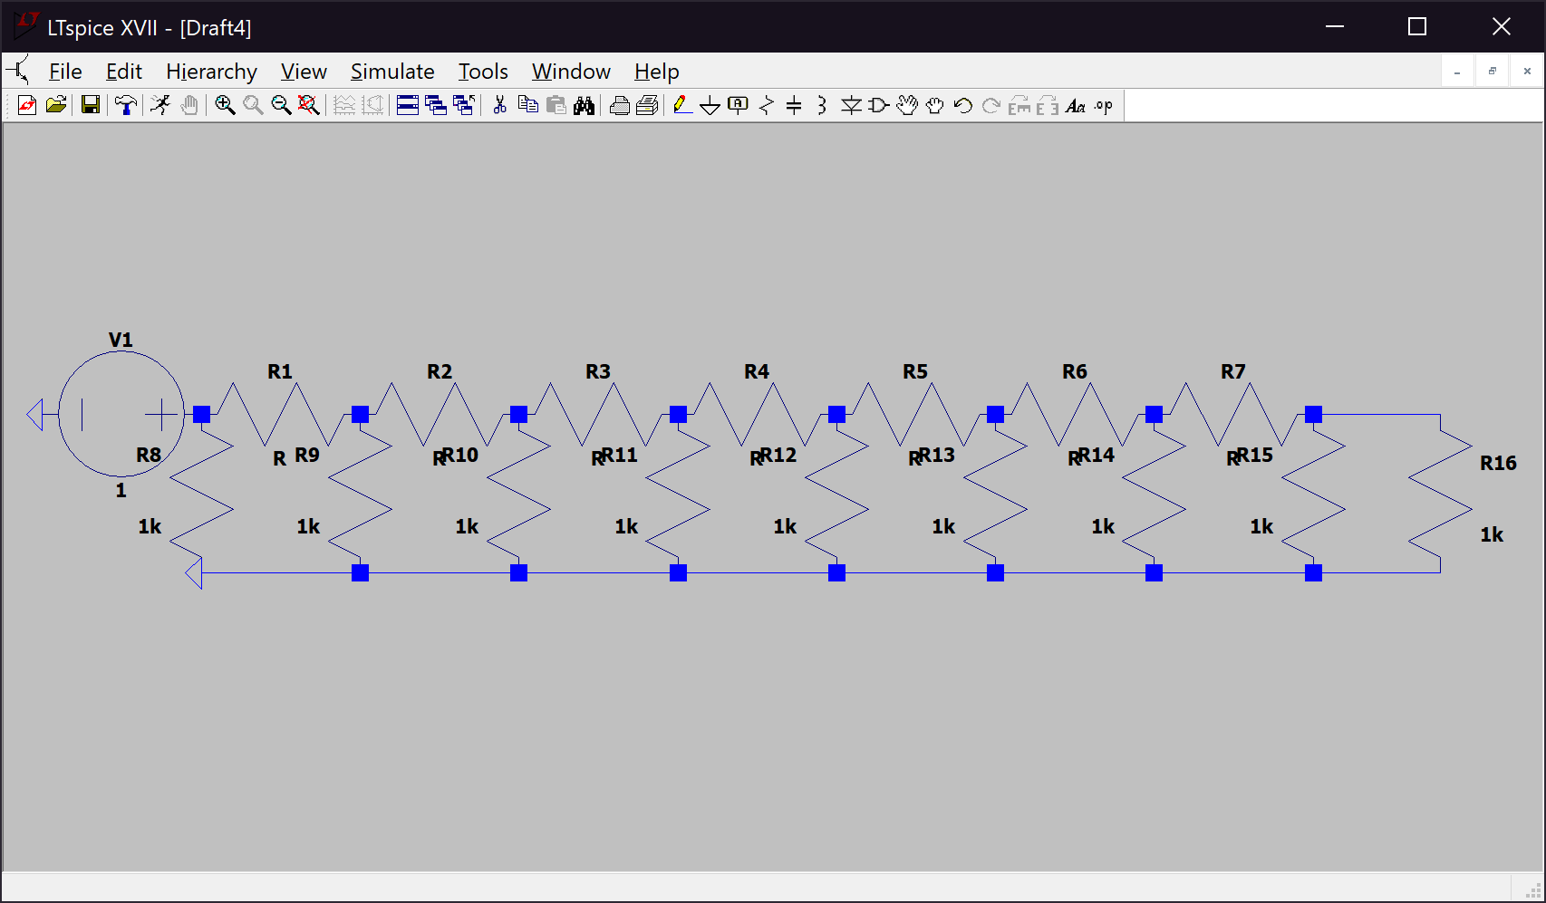 The current going through the source of the R-2R ladder, *Figure 1*, was measured twice, with the top row of resistors having 470 Ω and 500Ω.

*Figure 1. R-2R ladder*

In *Table 1.* the measured current and calculated equivalent resistance is shown.

*Table 1. Voltage, current, and equivalent resistance of the R-2R*

|  |  |  |
| --- | --- | --- |
| 2.5.1 | Resistors: 470 Ω | Resistors: 500 Ω |
| Voltage | 1 V | 1 V |
| Current | -0.00204196 A | -0.002 A |
| Equivalent Resistance | 489.73 Ω | 500 Ω |

The equivalent resistance in *Table 1.* was calculated with the formula:

The reason for the negative sign in front of the current is because LTSpice assign the direction of the current to go into the positive side of the voltage source, rather than going out of the positive side of the voltage source. We can see from *Table 1.* that when the resistors on the top side of the circuit have a resistance of 500 Ω, the equivalent resistance does indeed equal to 500 Ω due to the “cancelation” between the parallel 1,000 Ω resistors and 500 Ω resistors.

and so on…

**2.5.2 Monte Carlo with Different Tolerances**

*Figures 2-21* show the voltage ranges of nodes A, B, C, and D on separate plots with changing resistor tolerances.

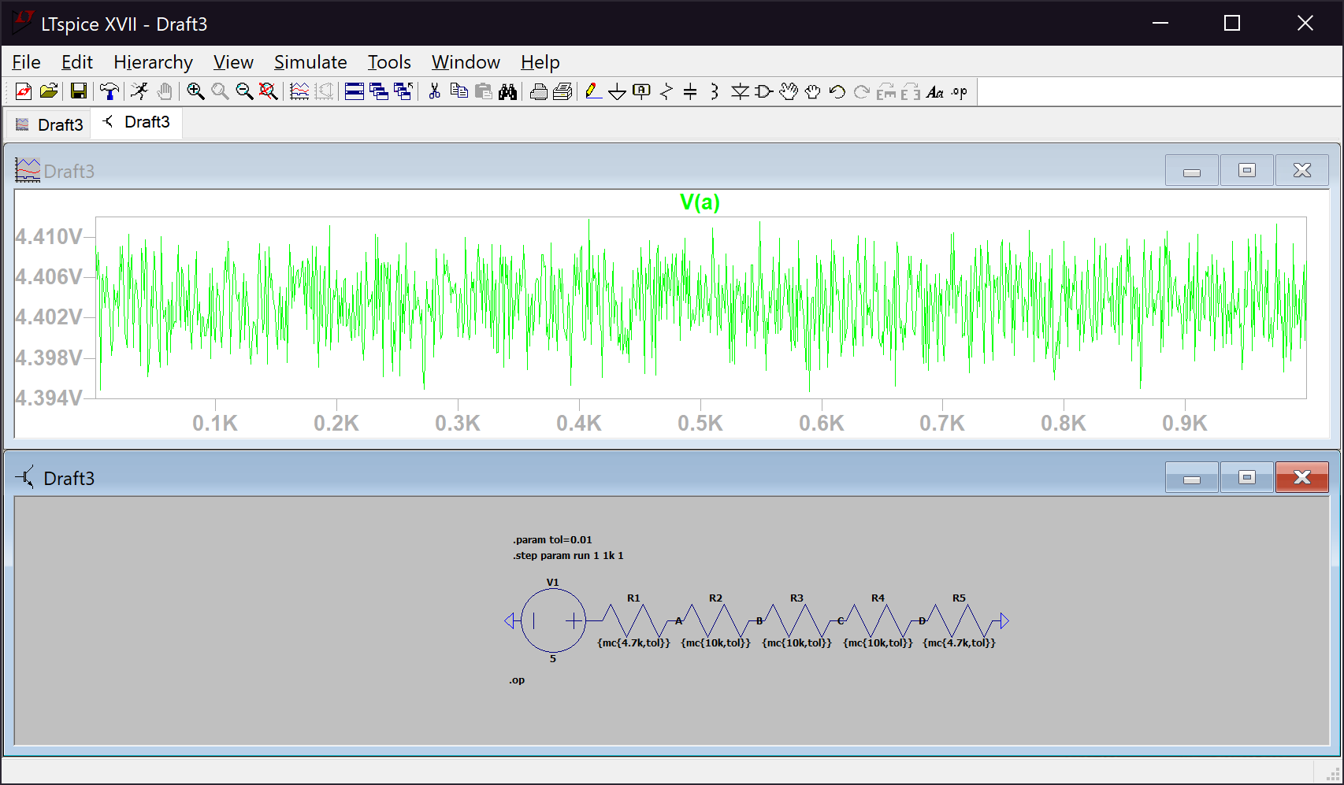*Figure 2. Voltage range at node A for resistors of 1% tolerance*

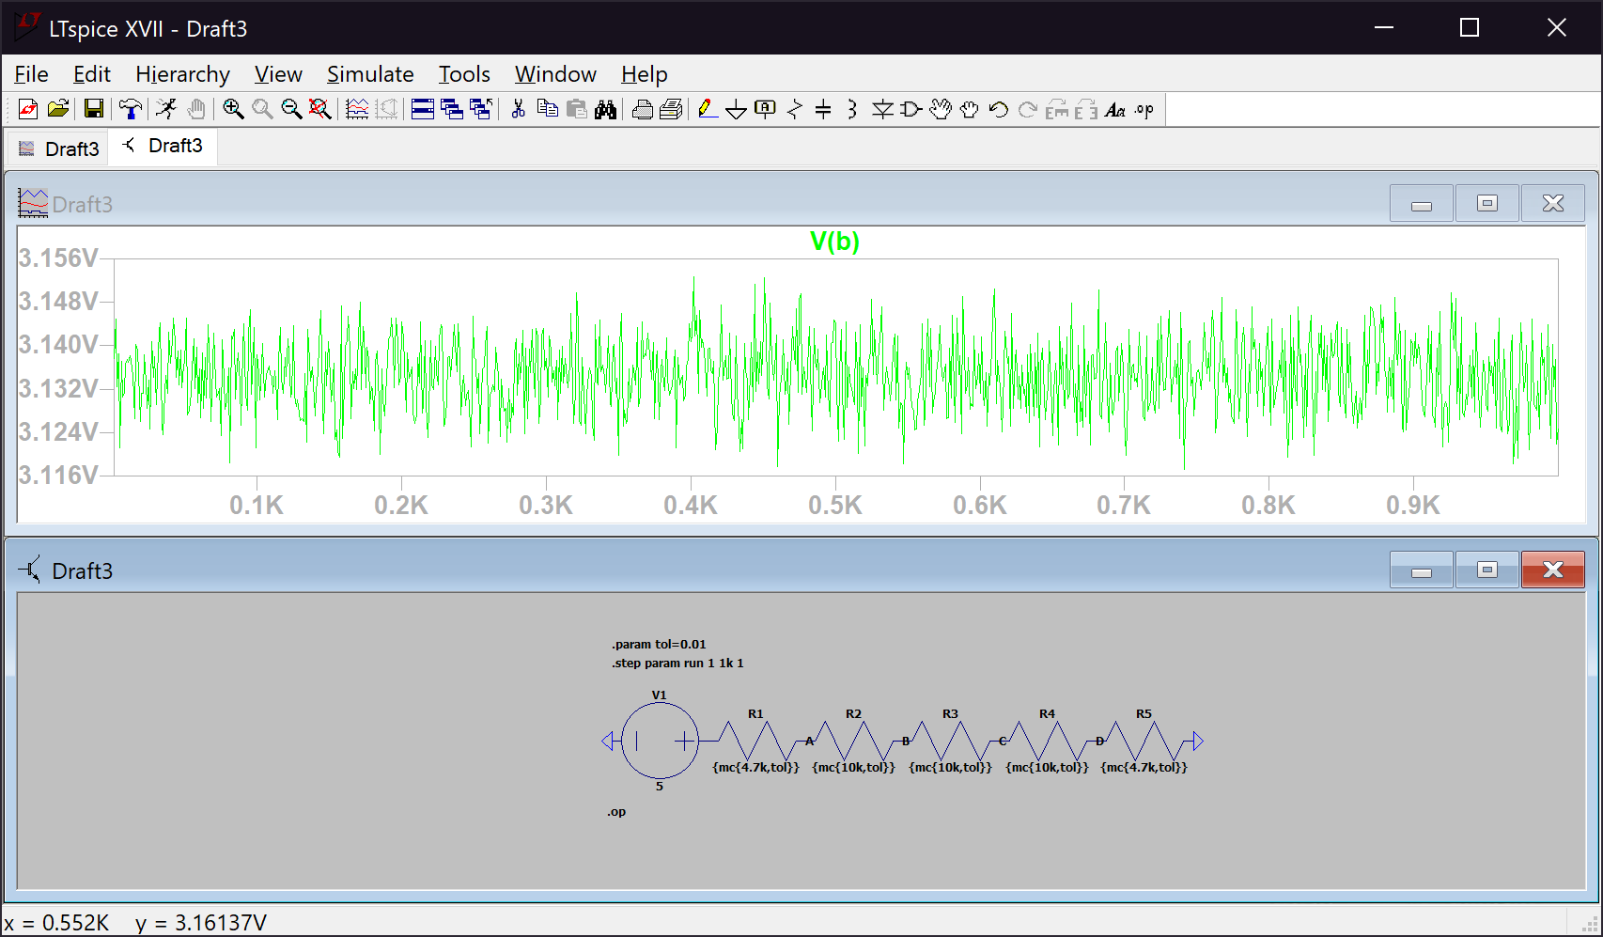

*Figure 3. Voltage range at node B for resistors of 1% tolerance*

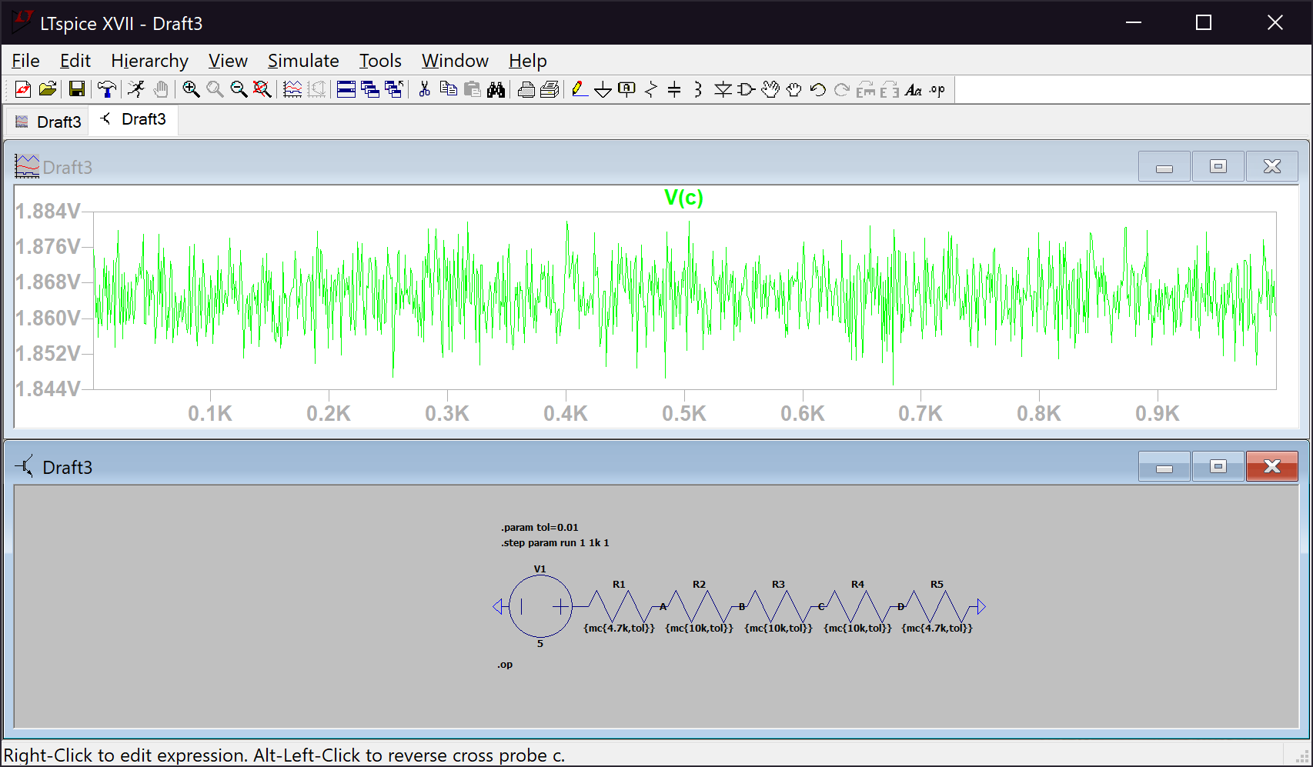*Figure 4. Voltage range at node C for resistors of 1% tolerance*

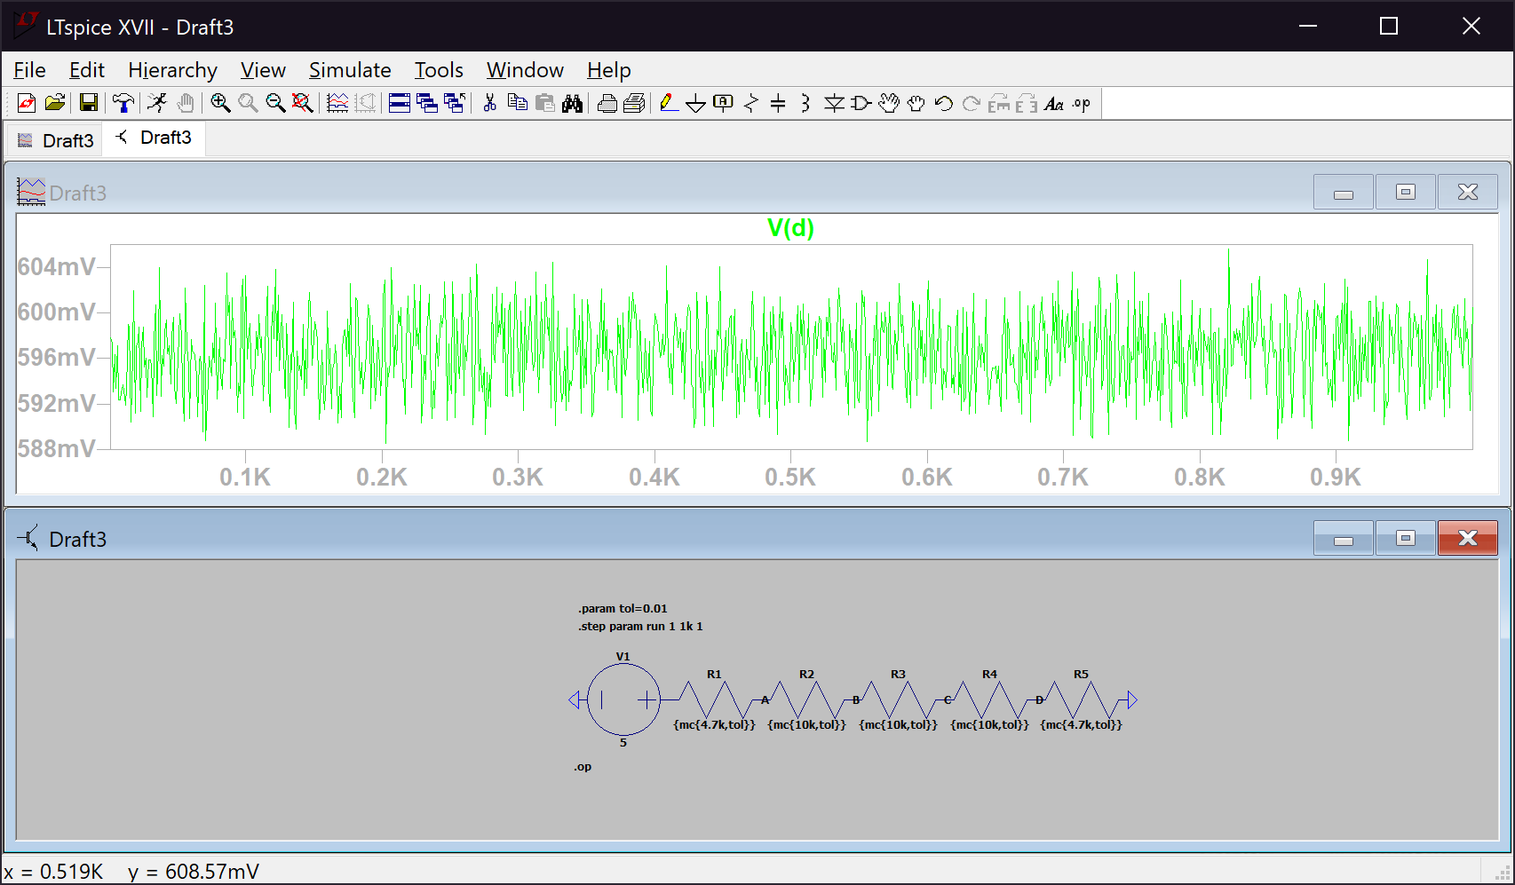

*Figure 5. Voltage range at node D for resistors of 1% tolerance*

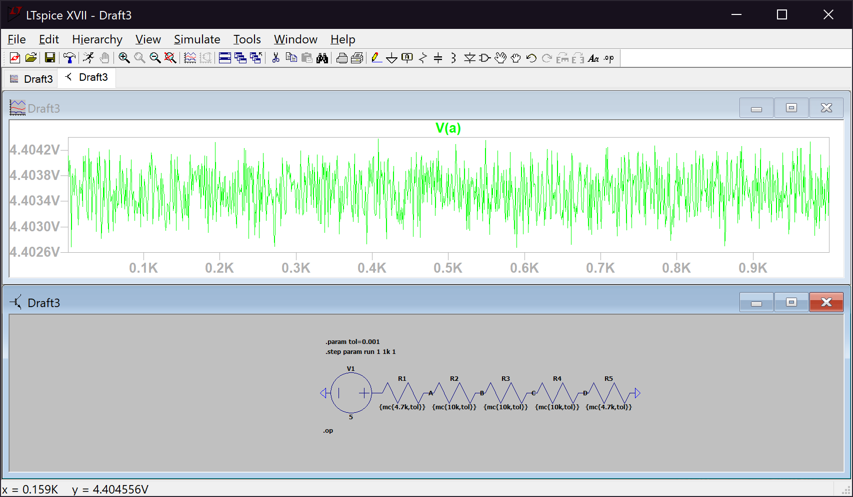*Figure 6. Voltage range at node A for resistors of 0.1% tolerance*

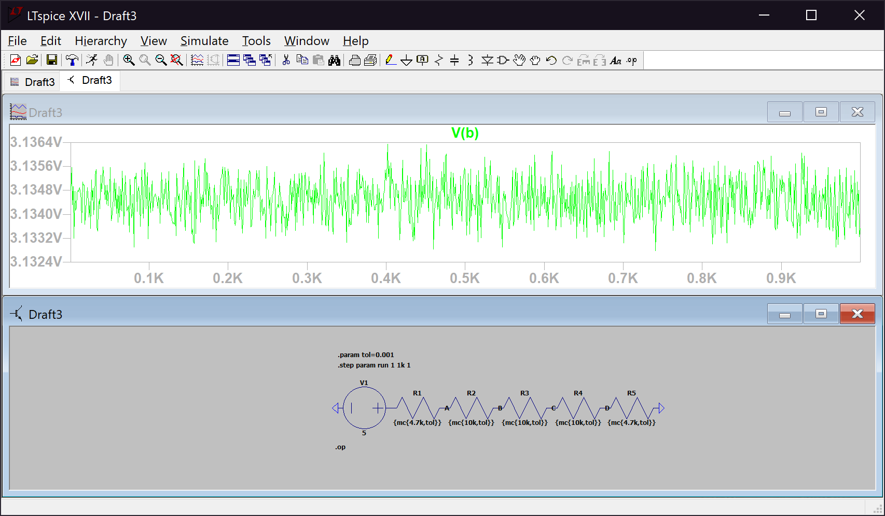

*Figure 7. Voltage range at node B for resistors of 0.1% tolerance*

*Figure 8. Voltage range at node C for resistors of 0.1% tolerance* 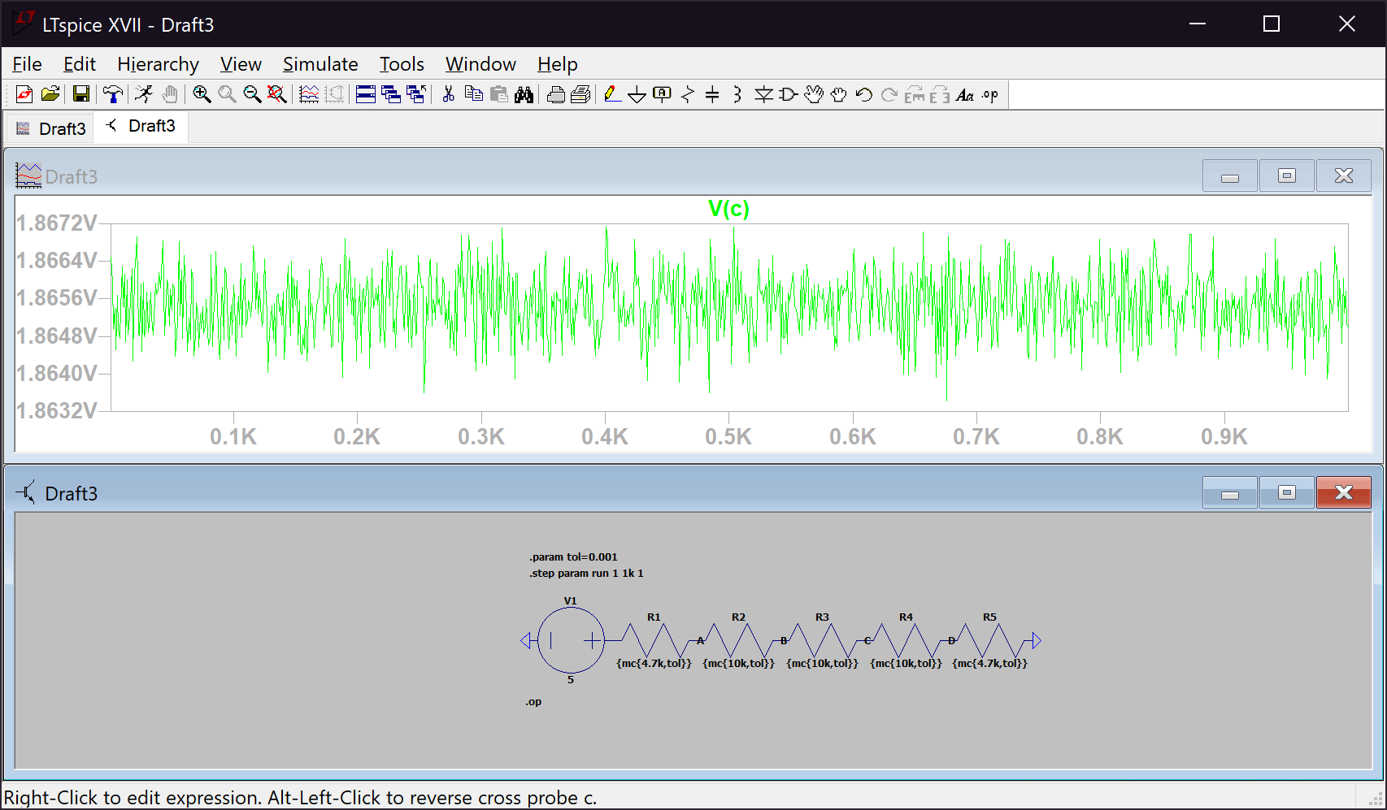

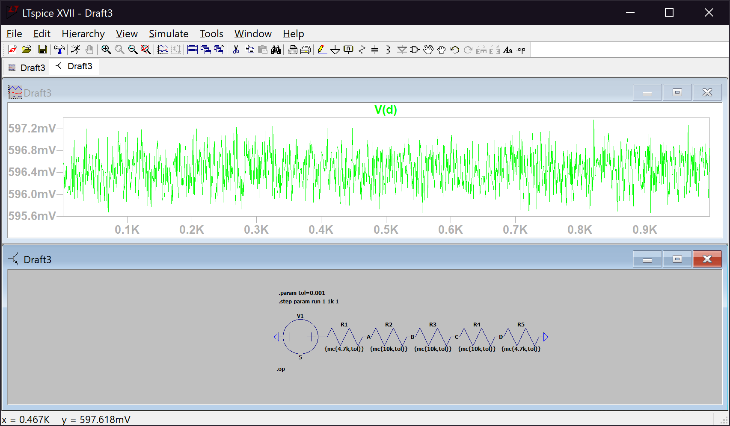

*Figure 9. Voltage range at node D for resistors of 0.1% tolerance*

*Figure 10. Voltage range at node A for resistors of 0.05% tolerance* 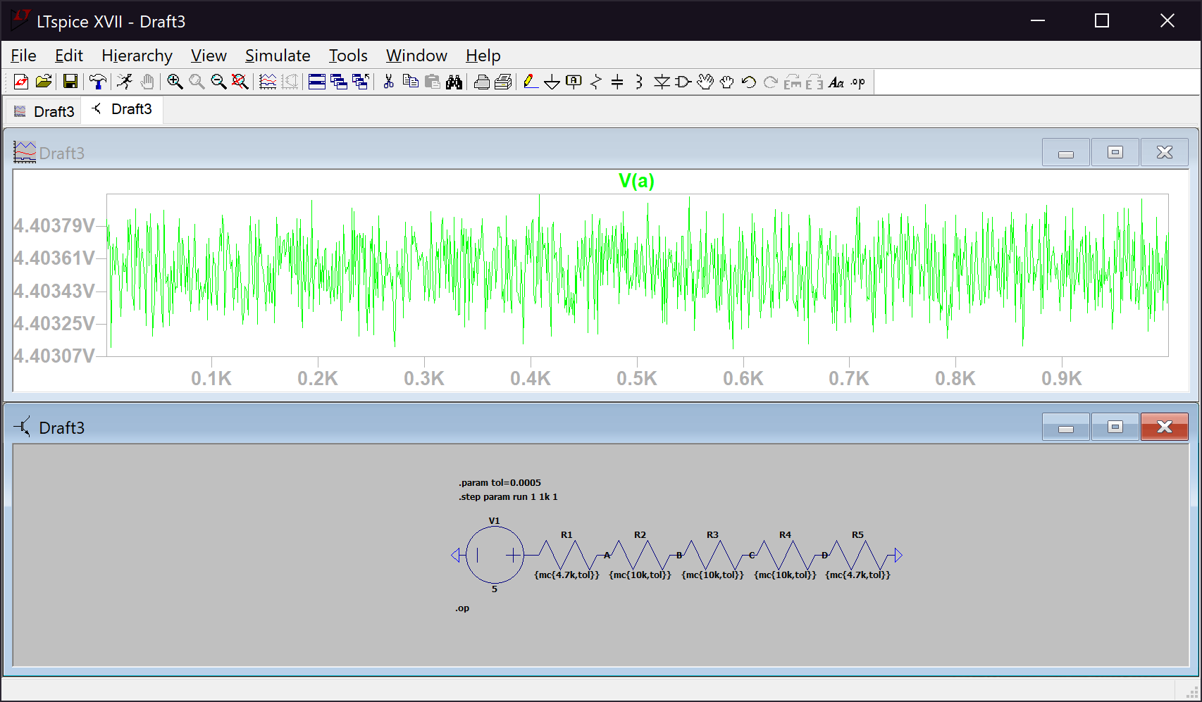

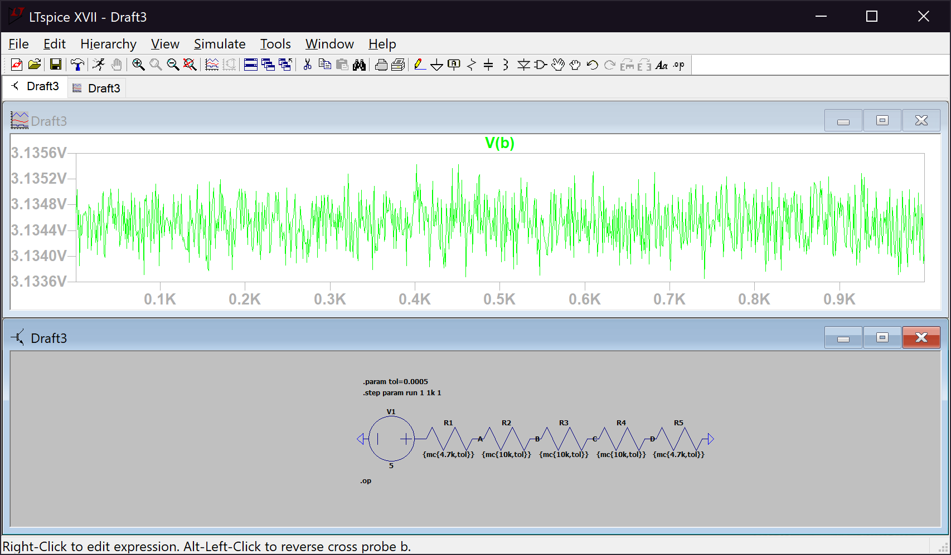

*Figure 11. Voltage range at node B for resistors of 0.05% tolerance*

*Figure 12. Voltage range at node C for resistors of 0.05% tolerance* 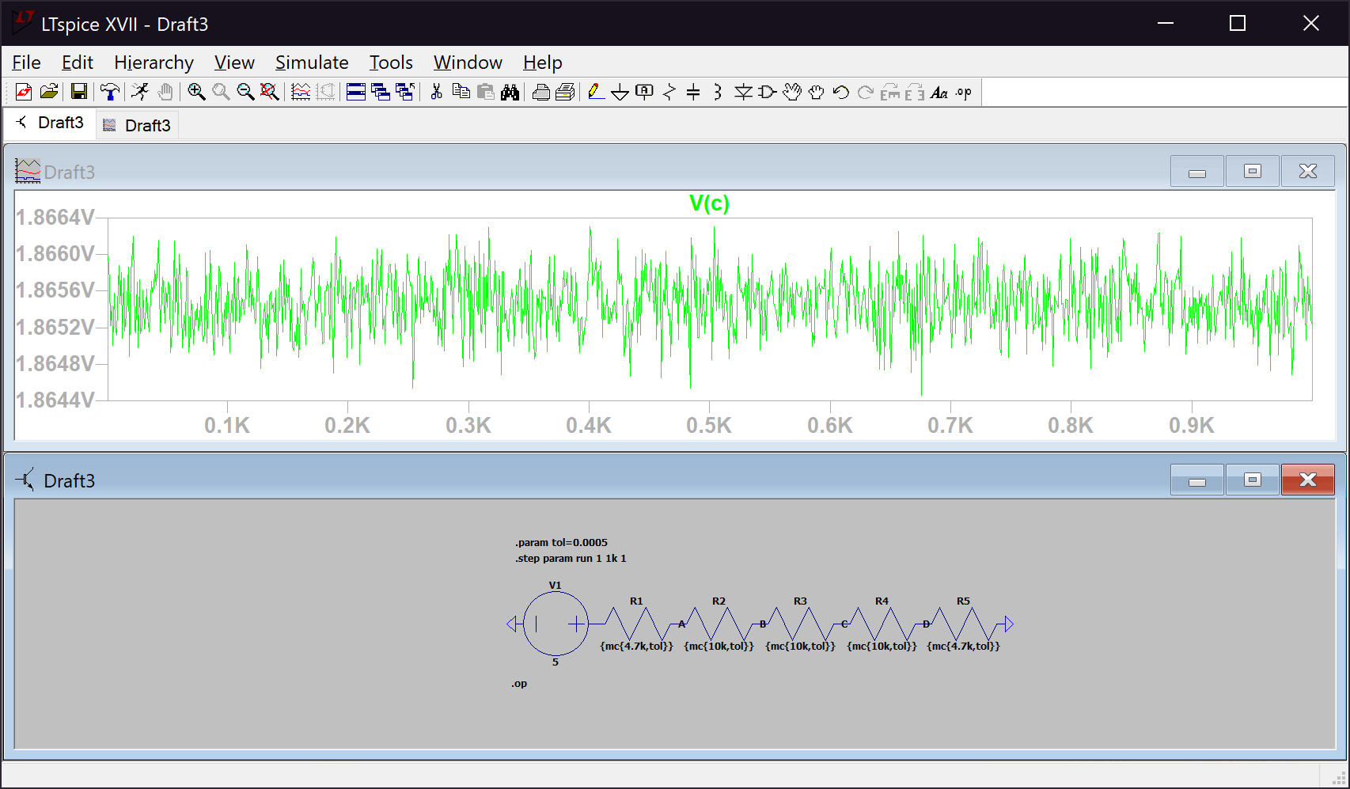

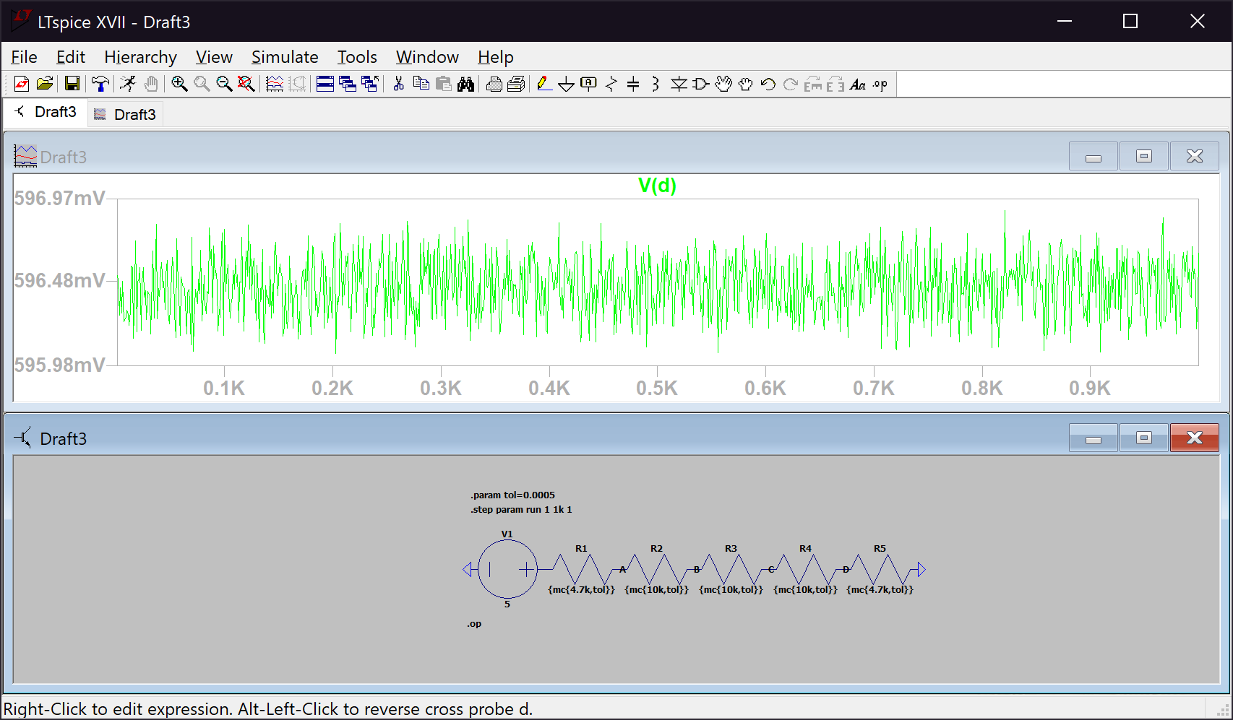

*Figure 13. Voltage range at node D for resistors of 0.05% tolerance*

*Figure 14. Voltage range at node A for resistors of 0.01% tolerance* 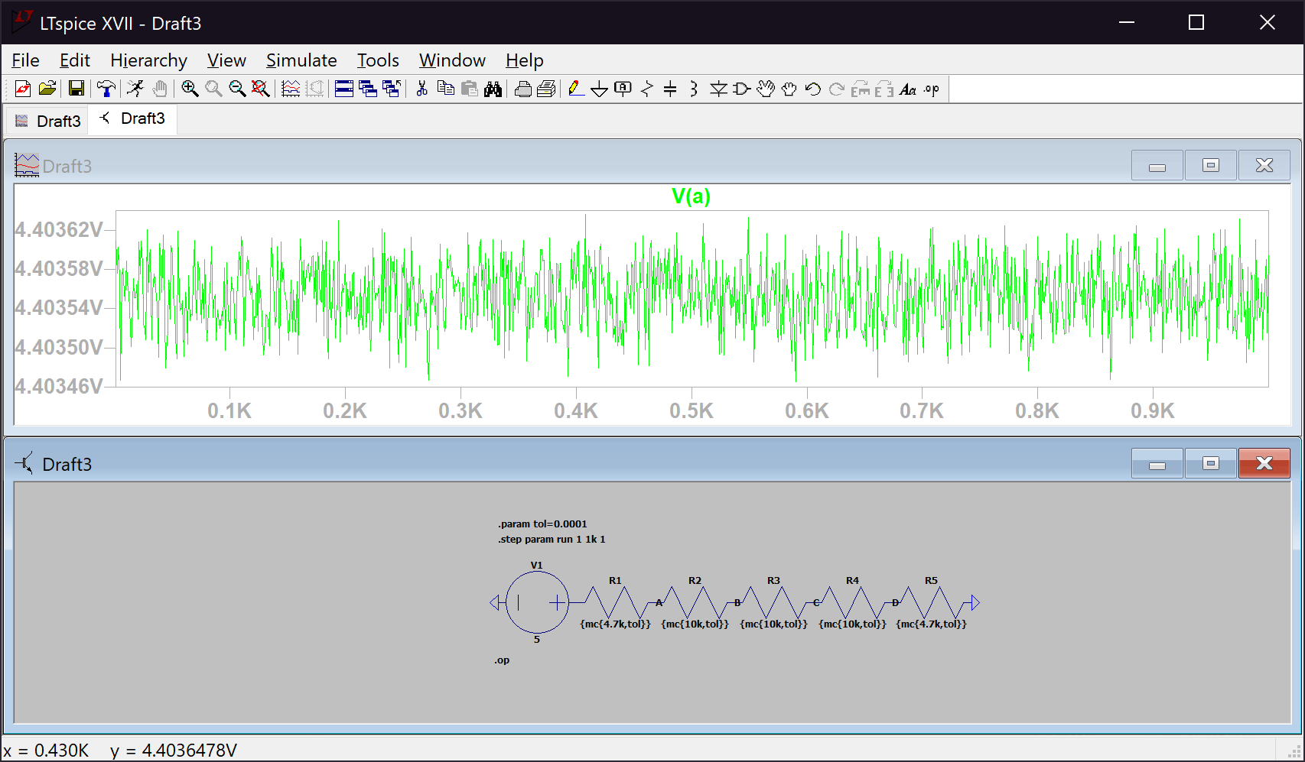

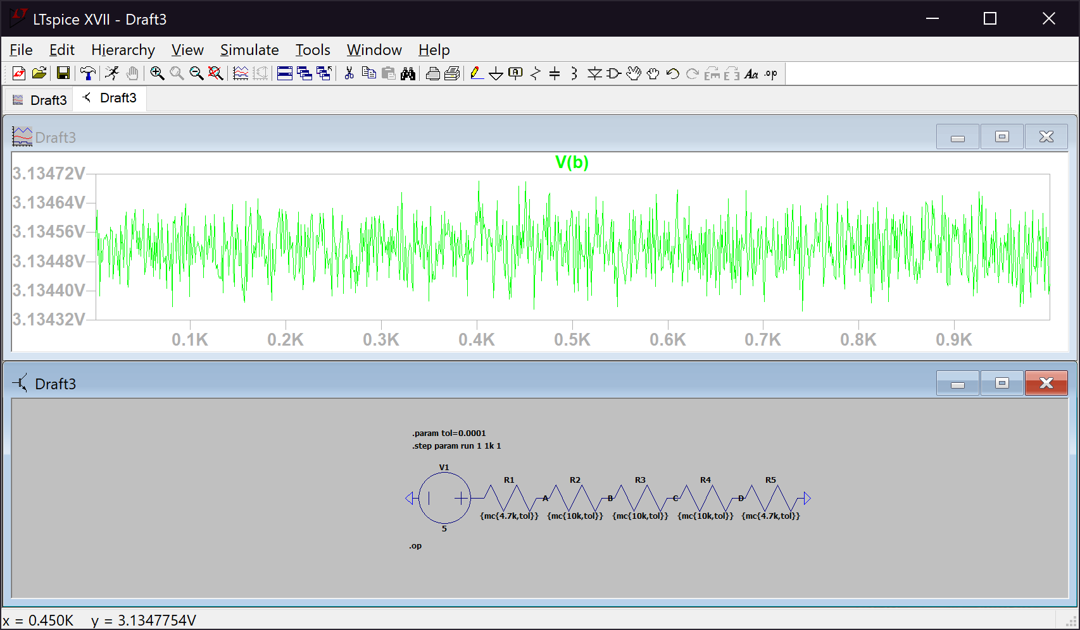

*Figure 15. Voltage range at node B for resistors of 0.01% tolerance*

*Figure 16. Voltage range at node C for resistors of 0.01% tolerance* 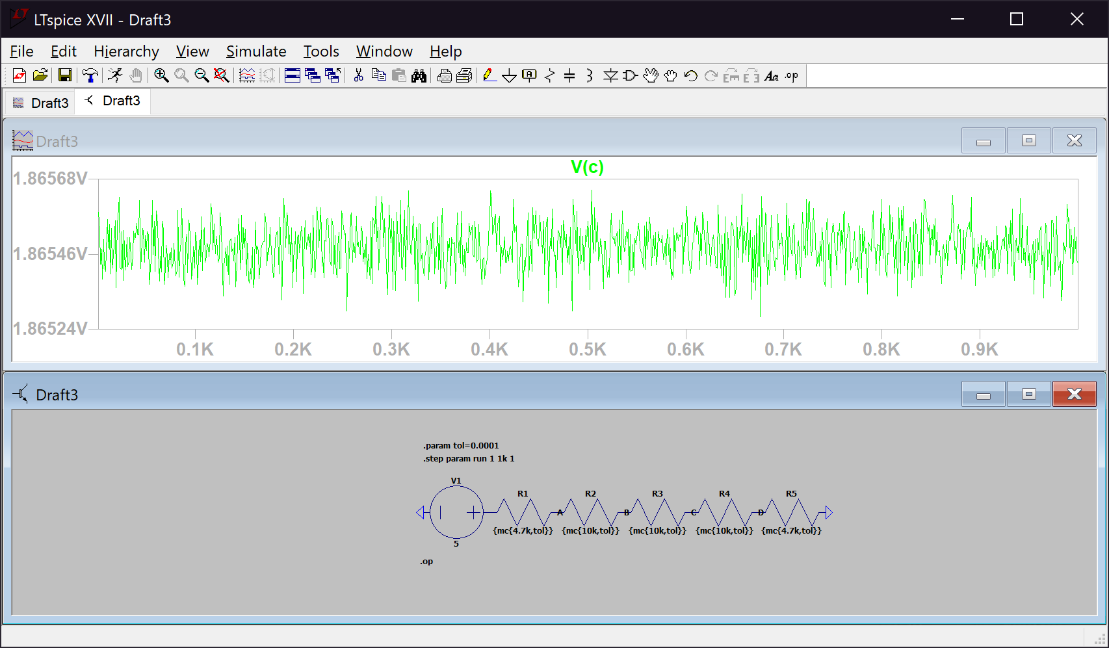

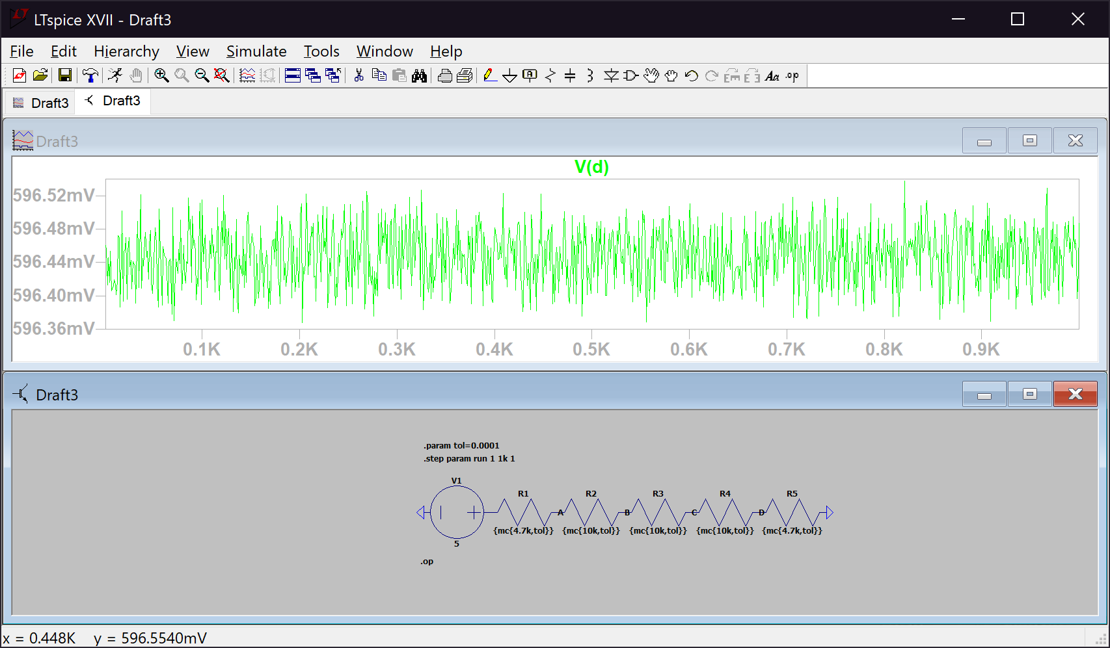

*Figure 17. Voltage range at node D for resistors of 0.01% tolerance*

*Figure 18. Voltage range at node A for resistors of 0.005% tolerance* 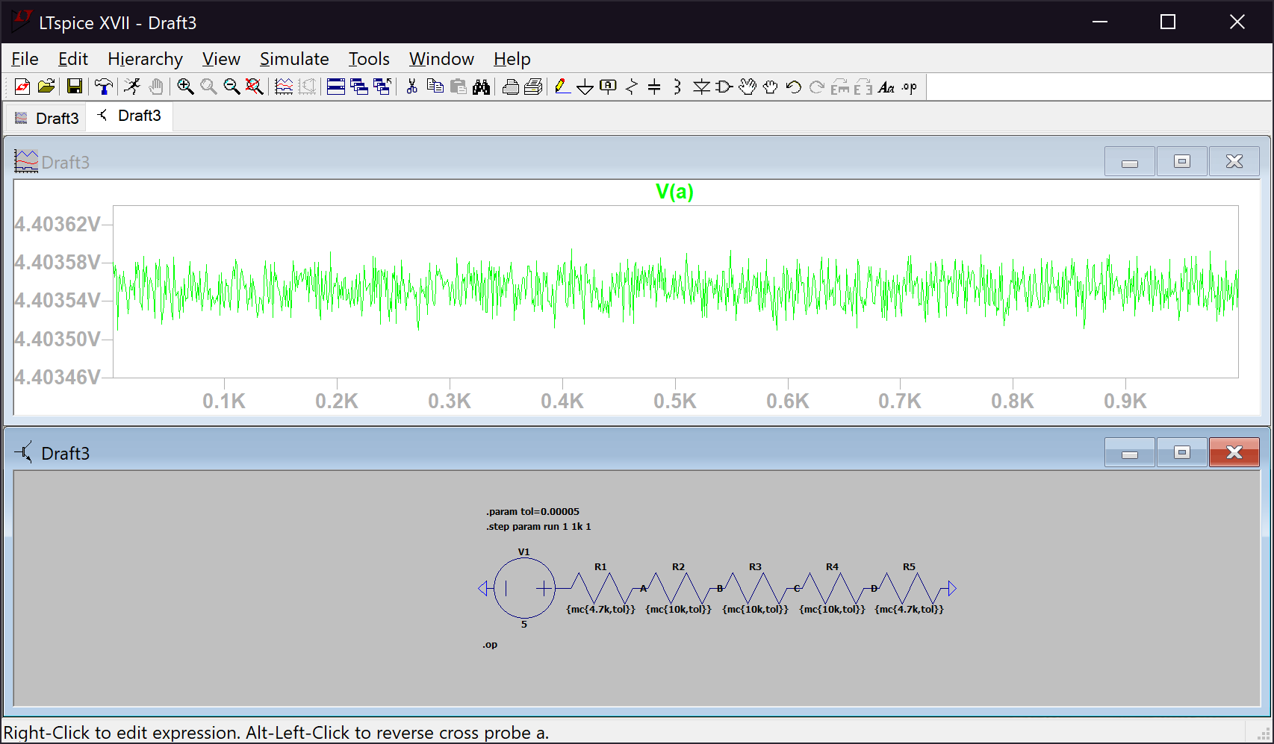

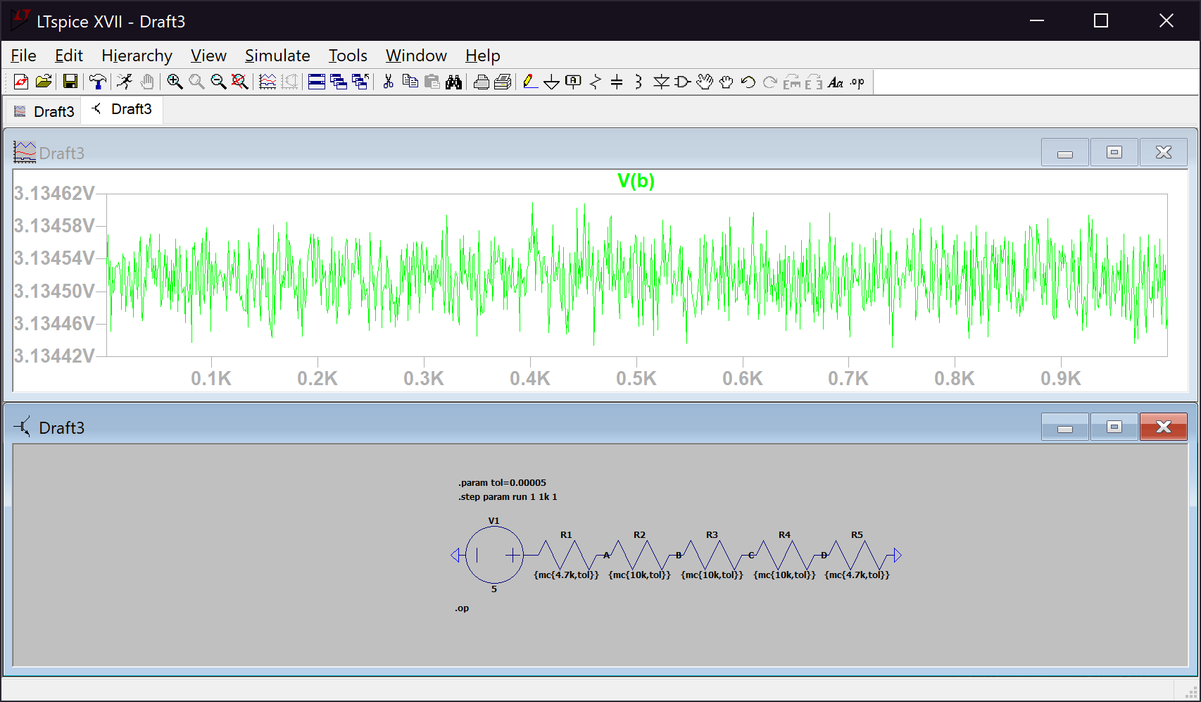

*Figure 19. Voltage range at node B for resistors of 0.005% tolerance*

*Figure 20. Voltage range at node C for resistors of 0.005% tolerance* 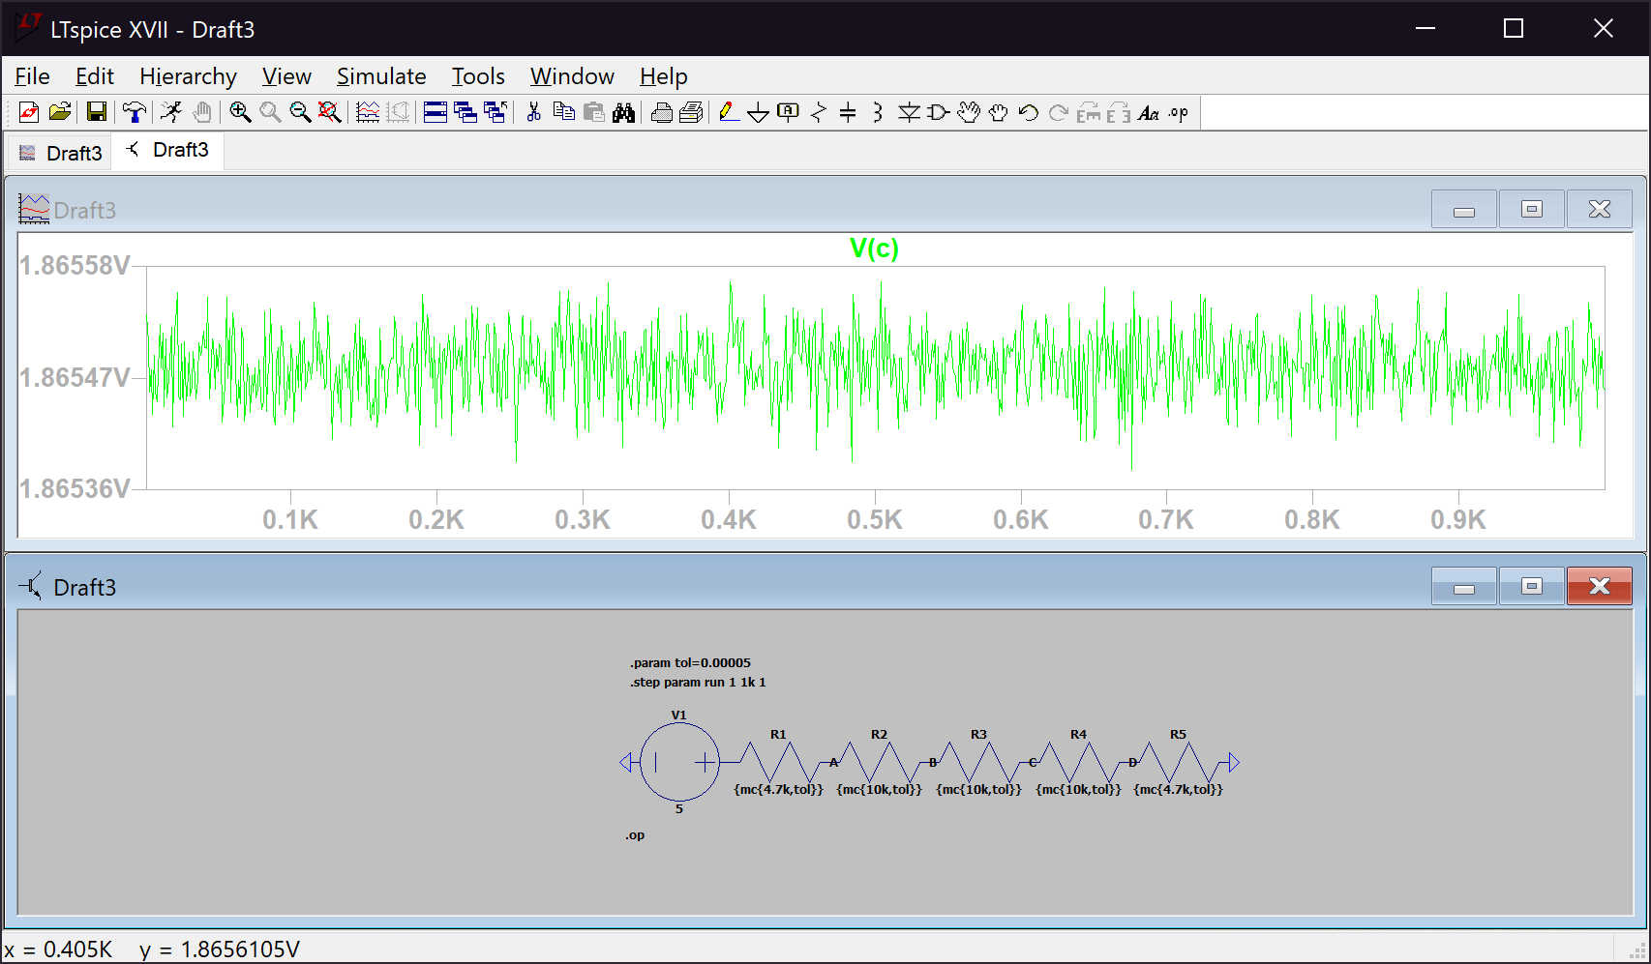

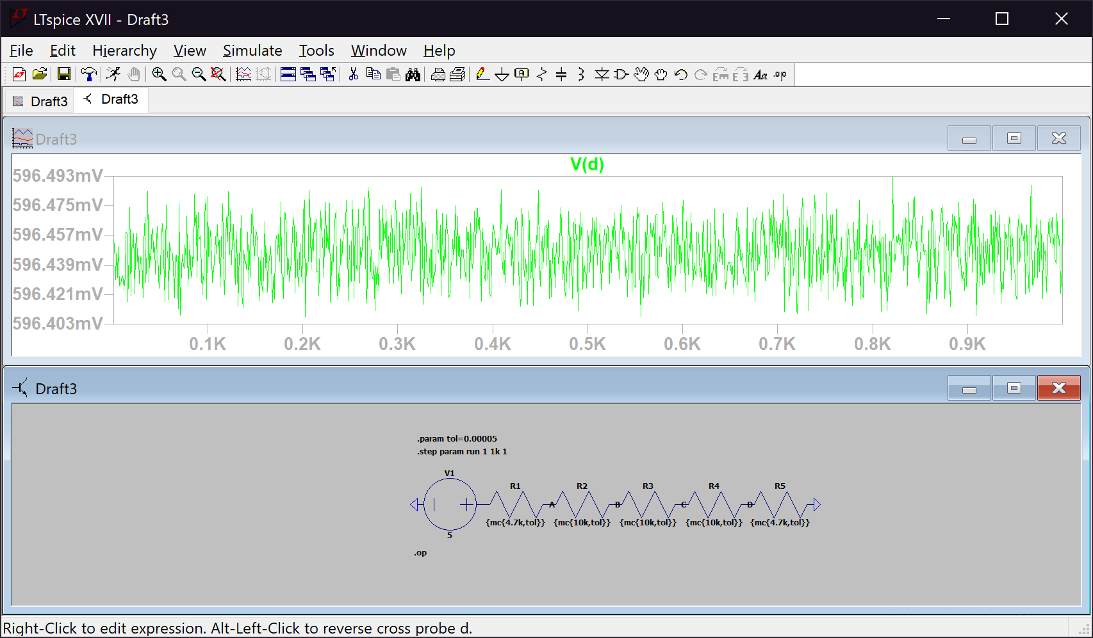

*Figure 21. Voltage range at node D for resistors of 0.005% tolerance*

In each figure we can see a plot of the voltage and the effect of resistor variation. Since resistors are not perfect have varying resistances proportional to their tolerance. That variation produces a spiky graph of the voltage rather than a straight line with a constant value for all 1000 measurements. Furthermore, the tolerance of a resistor describes the error of its resistance, meaning that the lower the tolerance, the more accurate the measurement. We can see this effect by looking at the value on the y-axis. For lower tolerances the range of the values on the y-axis are smaller than the values shown with higher tolerances. This means that lower tolerance means more precise values.

*Table 2. Voltages at different nodes with different resistor tolerances*

|  |  |  |  |  |  |
| --- | --- | --- | --- | --- | --- |
| 2.5.2 | Tolerance  1% | Tolerance 0.1% | Tolerance 0.05% | Tolerance 0.01% | Tolerance 0.005% |
| Node | Voltages [V] | Voltages [V] | Voltages [V] | Voltages [V] | Voltages [V] |
| A | 4.40465 | 4.40391 | 4.40376 | 4.4036 | 4.40353 |
| B | 3.14286 | 3.13498 | 3.13423 | 3.13452 | 3.13451 |
| C | 1.86683 | 1.86575 | 1.86564 | 1.86541 | 1.86545 |
| D | 0.598324 | 0.596234 | 0.596556 | 0.596477 | 0.596437 |

In *Table 2.* we can see varying values of voltages at the different nodes with different resistor tolerances. The voltage ranges fluctuate around some “correct” voltage value because of the tolerance of each resistor. We can conclude that the values of the “Tolerance 0.005%” are the most accurate since the error in resistance for those resistors was the least.

**2.5.3 Resistor Costs**

Lower tolerance means more precise and accurate readings, which make them more wanted, however this leads to high prices of lower tolerance resistors.

*Table 3. Price ranges of resistors with different tolerances*

|  |  |  |
| --- | --- | --- |
| 2.5.3 |  |  |
| Tolerance | Price - Low | Price - High |
| 5% | $0.10 | $10.35 |
| 1% | $0.10 | $8.05 |
| 0.1% | $0.59 | $4.84 |
| 0.05% | $2.57 | $3.90 |
| 0.01% | $5.18 | $50.14 |
| 0.005% | $26.79 | $72.36 |

We can see from *Table 3.* that because of the benefit of lower tolerance, lower tolerance resistors are more expensive. For example, at 5% tolerance, the lowest price is $0.10 while the lowest price for 0.005% tolerance is $26.79, more than the highest price of a 5% tolerance resistor, $10.35.

**Conclusion**

In this lab we concluded that the equivalent resistance of a R-2R ladder is equal to R. Resistors have natural variation which lead to rough voltage plots instead of a straight constant line. Moreover, higher tolerance leads to more inaccurate readings and lowering preciseness and vice versa. As a result, higher tolerance resistors are cheaper than lower tolerance resistors.